You are a Senior Spring Boot Architect, Technical Trainer, and LinkedIn Tech Content Strategist.

I am running a 100-day deep Spring Boot + Java backend preparation series for interview readiness and real-world engineering mastery.
Assume that u are subject matter expert for Spring + Spring Boot , teaching spring boot for student who is beginner but end of this day he should be perfect and clear end to end in this topic.

DAY 22: Today’s topic : JPA Architecture & Entity Lifecycle
What is Entity?
Spring Data JPA is just an abstraction on top of JPA(layer on top of JPA), Let’s deep dive into the JPA and It’s Architecture
JPA Architecture
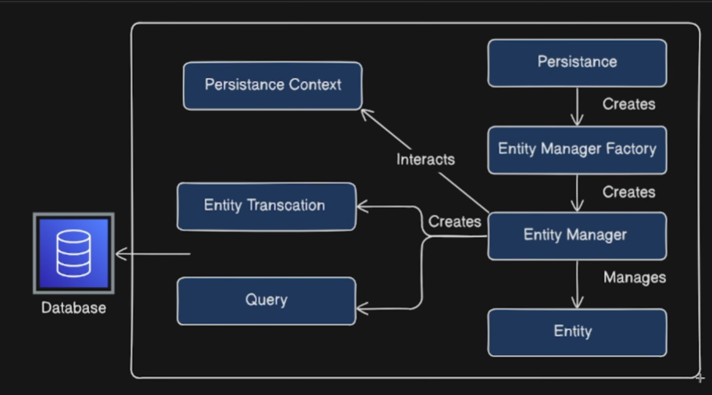
Journey of Entity to Database ?
Entity is managed by Entity Manager .
Entity Manager is an interface inside java for managing entities in our application, all the operations that we arate ie doing on this entity in the application is done by or taken care by entity manager (Operations like Save,Remove etc)
Entity Manager Factory is Responsible of Creation of this Entity Manger
Persistence creates Entity Manager Factory
Persistence Context : it is a cache where these entities will be stored temporarily. It is bag which stores the entities in our application and Entity Manager interacts with Persistence Context for entities to manage.
Entity Manager is an interface/abstraction layer it cannot interact with database directly so it creates Query,Entity Transaction.
we already knew Hibernate is the internal Implementation for JPA.
This Entity Manager Offloads the task of interacting with database part to (Entity Manager,Query) Hibernate
Hibernate will creates it’s own Queries (HQL) SQL Queries Based on the requirement that we are getting from Entity Manager

Entity LifeCycle
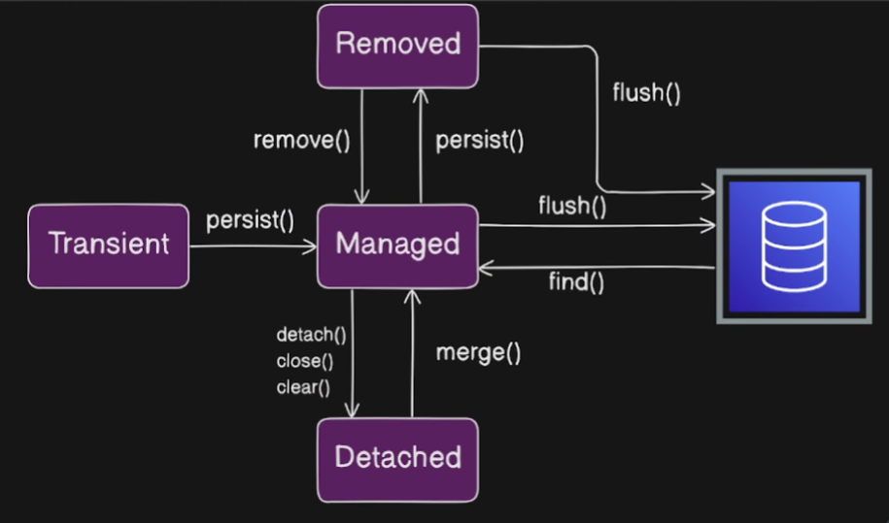
States:
Transient,Managed,Detached,Removed

When we create a new Application
- The moment when we create the entity in application
- it will be in Transient state ( this is basically state of new entity) Fresh Entity at this state it is not yet managed by entity manager
- The moment when we persists the entity
- Persist()
- Entity managed by Entity Manager.
Once Entity.persist() then the state of entity is changed from Transient State to Managed State.
- Now the bean/entity is in managed State
- when ever the bean is in managed state it is associate with Persistence Context
- The bean is added into Persistence Context
- Entity Manager Interacts with Persistence context to manage the entities
- Persistence Context will store the managed Entities
- Once our entity is in managed state whatever the changes that we do on this entity will synchronize with the database
- Flush() Saves the entity in database when transaction commits data will be added over here in database Saves inside the database
- Find() finds the entity from database
- Detach(),close(),clear() the entity state is changed from Managed state to Detached State
- Once entity reaches this Detached state Entity will not be managed by Entity Manager these entities were once managed by entity manager thru Persistence Context Will be Detached State
- If we want to move it Managed state back Merge() Detaced state to Managed State
- Remove() Managed State to Removed state
- Persist() Removed State to Managed State
- Flush() From Removed state it make changes to Database

Use the above content and need all the content mentioned above also take the suggestions below

I want TWO outputs:
========================================
PART 1 — LINKEDIN POST (High Reach Version)
========================================

Write a short, crisp, high-engagement LinkedIn post that:
• Uses a real-life analogy or scenario (like Mani & Mini, office workflow, friends, team conflicts, etc.)
• The analogy must map clearly to the Spring concept
• The story should be funny, relatable, and memorable
• Use real Spring terminology inside the story (Bean, IoC, Container, Configuration, Dependency, etc.)
• Create curiosity in the first 2 lines (strong hook)
• Make people WANT to read the document
• End with a call-to-action: Save | Follow | Comment | Read
• Keep it short enough for daily posting (not long blog style)

Include:
• Emojis (but not excessive)
• 1--15 relevant hashtags (#SpringBoot #Java #Backend #Interviews #100DaysOfCode etc.)
• A powerful ender line

Do NOT include code in the LinkedIn post.

========================================
PART 2 — MASTER TECHNICAL DOCUMENT
========================================

Write a **go-to reference document** for this topic.

This document must be:
• Extremely clear
• Interview-grade
• Real-world engineering grade
• Step-by-step
• Code-heavy where needed
• Properly structured
• Easy to revise before interviews

The document must include:

1️⃣ **Concept Foundation**
• Why this concept exists
• What problem it solves
• Where it fits in Spring Boot architecture

2️⃣ **Core Definitions**
• Define all key annotations and terms involved
• (@Component, @Configuration, @Bean, Auto-config, BeanFactory, ApplicationContext, etc.)

3️⃣ **How Spring Actually Executes This**
• Startup flow
• Which annotation is read first
• How Spring decides what to create
• What happens internally

4️⃣ **Code Examples**
• Minimal example
• Real-world style example
• Show both correct and problematic cases
• Show how Spring behaves in each

5️⃣ **Differences Table**
• Compare related annotations (e.g. @Component vs @Configuration, @Bean vs @Component, etc.)

6️⃣ **Hidden Traps**
• Circular dependency risks
• Proxy behavior
• Bean duplication
• Startup failures
• Why things work in Boot but not in Core Spring

7️⃣ **Interview Angle**
• Why interviewers ask this
• What they actually want to test
• Common wrong answers
• Correct framing

8️⃣ **Most Asked Interview Questions (with Answers)**
• 10–15 high-quality questions
• Mix of theory + scenario + code based
• Answers must be short, crisp, and technically correct

9️⃣ **One-page Mental Model Summary**
• How to remember this topic in real projects

10️⃣ **End Section**
• Key takeaways
• Why this topic matters in enterprise systems
• How it connects to future topics (Boot, Auto-config, AOP, Security, etc.)

========================================

Style Rules:
• Do NOT be dry
• Be clear, authoritative, and professional
• Avoid textbook tone
• Use real-world language
• Assume reader is preparing for backend interviews
• No fluff, only high-signal content

End of the document should have Summary as A Story :
From start to end of the spring Boot Application where we write this and how spring boot uses this or flow of events happening including this part.
This document should feel like:
"The one PDF a serious Spring Boot backend engineer would keep before interviews."

Start with the topic title as a heading.
End the document with a divider line and a “Follow & Save for the next topic” call-to-action.

